Prog 3 Test Results
Test Name | Result
testRecentWeek | Pass
testMaxMinPlayerScores | Pass
testTotalPointsOver500 | Pass
testMonthAveragePoints | Pass
testAccumulatedTeamPoints | Pass

Notes
Test 5 assisted in the discovery of a fairly important bug in the accumulatedTeamPoints function where I was adding the size of the team to the total points which was incorrect as we only want the total points not the total points + the number of players in the team. I had to fix this bug in the Analysis.scala file and once updated, invoked test 5 to verify the fix.

Screenshots of each test are shown below.

testRecentWeek
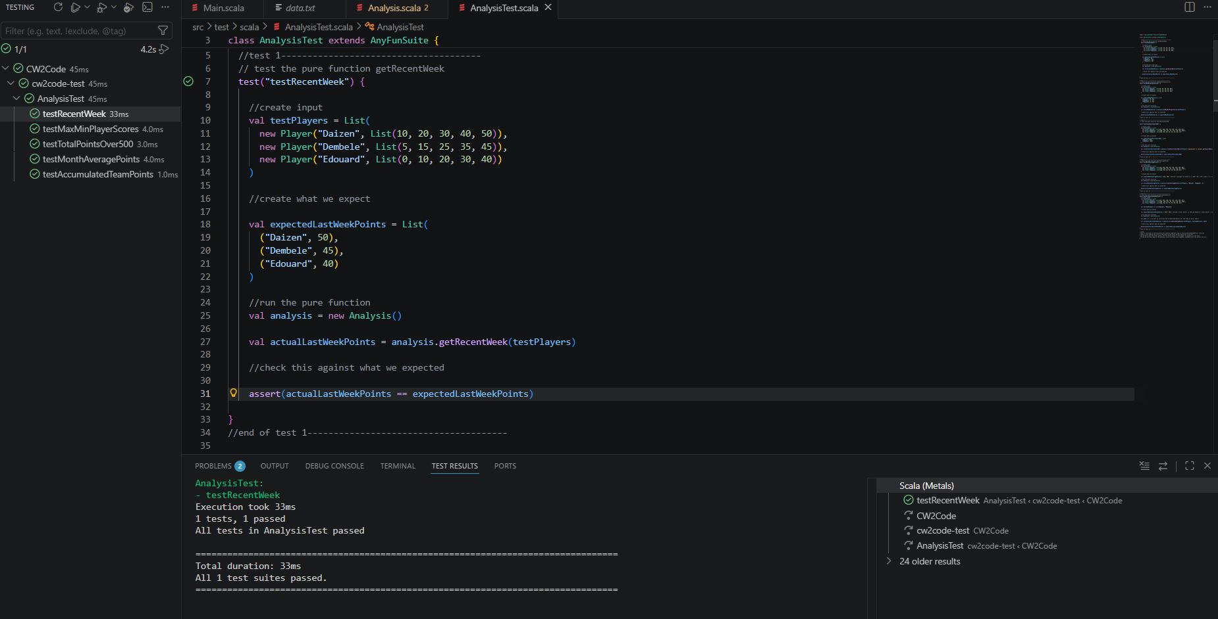

testMaxMinPlayerScores
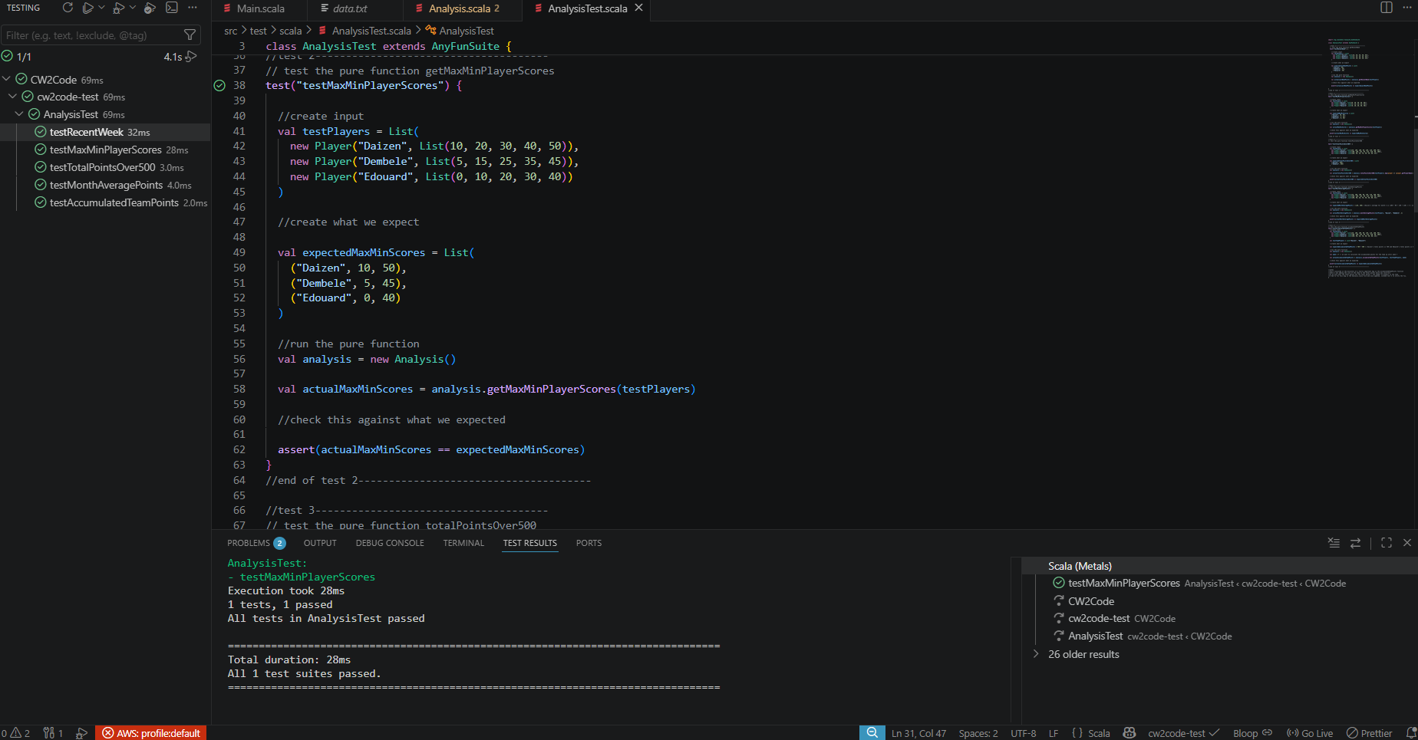

testTotalPointsOver500
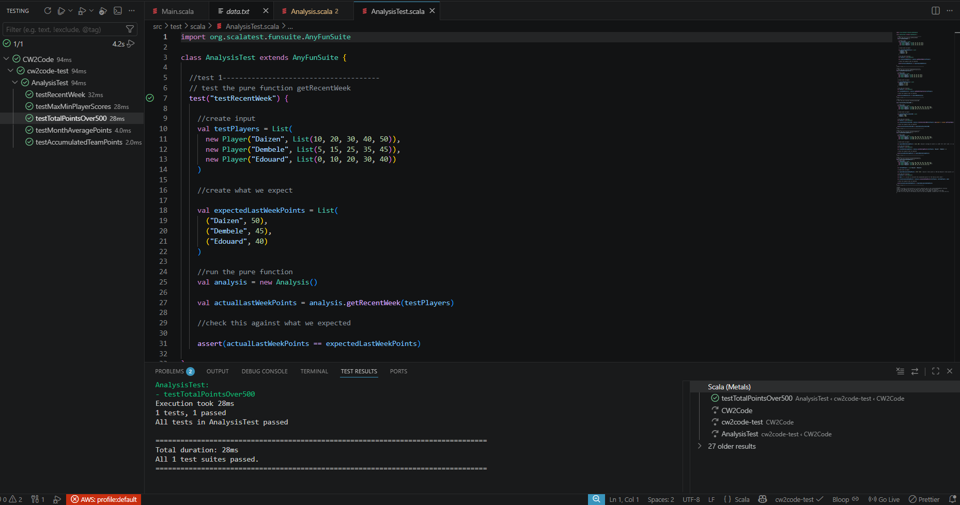

testMonthAveragePoints
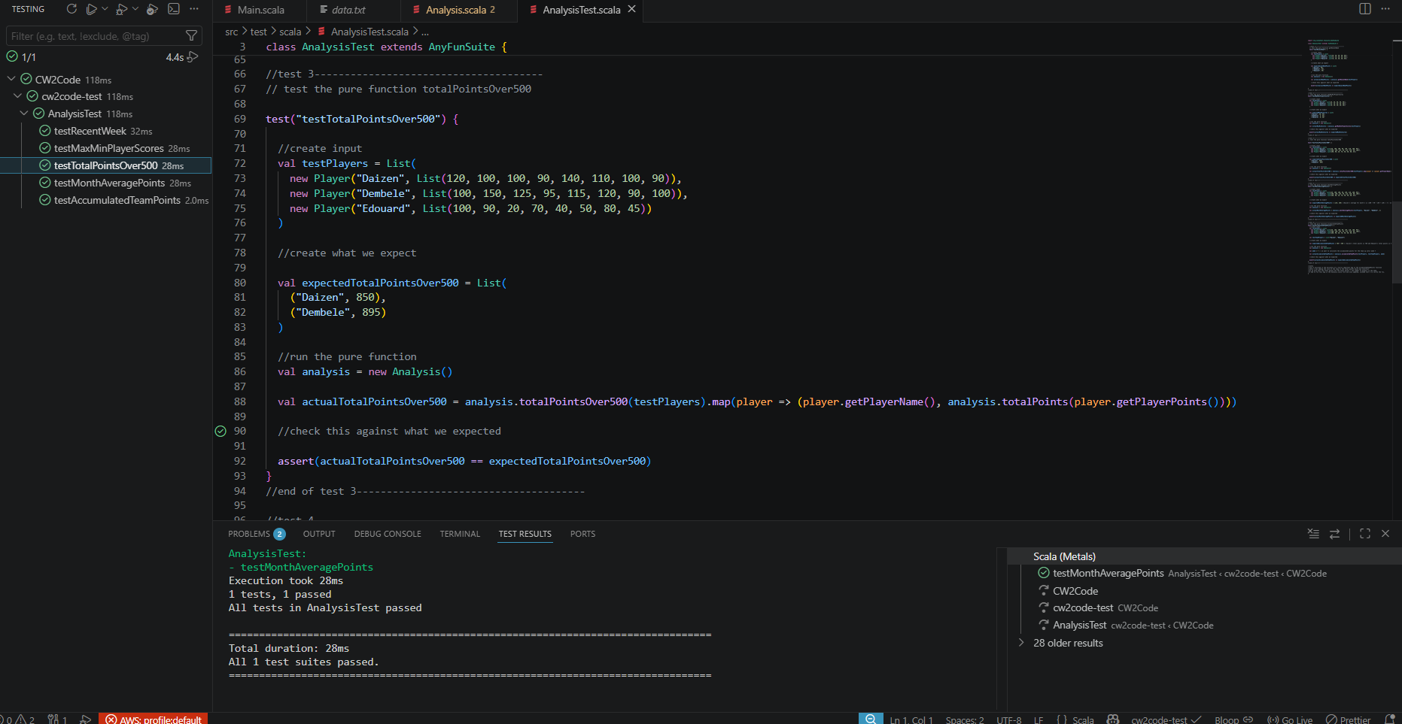

testAccumulatedTeamPoints
